//Program on String Class
1. Write a java program to implement all constructor process
class Test
{
public static void main(String srgs[])
{
String s1=new String();
s1="Anand";
String s2="abcde";
String s3=new String("abcde");
char c[]={'a','b','c','d','e'};
String s4=new String(c);
System.out.println(s1);
System.out.println(s2);
System.out.println(s3);
System.out.println(s4);
}
}
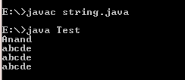

2. Write a java program to implement the following methods (charAt,codePointAt,codePointBefore,codePointCount).
class Test
{
public static void main(String srgs[])
{
String s1=new String();
s1="Anand";
System.out.println("charAt= "+s1.charAt(2));
System.out.println("codePointAt= "+s1.codePointAt(2));
System.out.println("codePointBefore= "+s1.codePointBefore(2));
System.out.println(" codePointCount= "+s1.codePointCount(0,4));
}
}
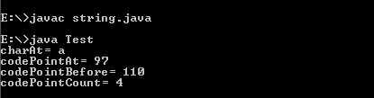
3. Write a java program to implement the following methods
(equals,equalsIgnoreCase,compareTo -> (equal string length,different length, change in character, equal character should be implemented seperately),compareToIgnoreCase -> (equal string length,different length, change in character, equal character should be implemented seperately)).
3.1;//Equal & equal ignorecase
class Test
{
public static void main(String args[])
{
String s1=new String("abcd");
String s2=new String("abcd");
String s3=new String("abch");
String s4=new String("abcdefghijkl");
String s5=new String("abcD");
System.out.println("Equals "+s1.equals(s2));
System.out.println("Equals "+s1.equals(s3));
System.out.println("Equals "+s1.equals(s4));
System.out.println("Equals "+s1.equals(s5));
System.out.println("EqualsIgnoreCase "+ s1.equalsIgnoreCase(s2));
System.out.println("EqualsIgnoreCase "+ s1.equalsIgnoreCase(s3));
System.out.println("EqualsIgnoreCase "+ s1.equalsIgnoreCase(s4));
System.out.println("EqualsIgnoreCase "+ s1.equalsIgnoreCase(s5));
}
}
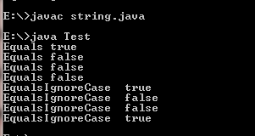

3.Compare & compare to ignore
class Test
{
public static void main(String srgs[])
{
String s1=new String("Anand");
String s2=new String("Anand");
String s3=new String("Anan");
String s4=new String("And");
String s5=new String("An");
String s6=new String("AnAnd");
System.out.println("compare= "+s1.compareTo(s2));
System.out.println("compare= "+s1.compareTo(s3));
System.out.println("compare= "+s1.compareTo(s4));
System.out.println("compare= "+s1.compareTo(s6));
System.out.println("compare To Ignore case = "+s1.compareToIgnoreCase(s2));
System.out.println("compare To Ignore case= "+s1.compareToIgnoreCase(s3));
System.out.println("compare To Ignore case = "+s1.compareToIgnoreCase(s4));
System.out.println("compare To Ignore case = "+s1.compareToIgnoreCase(s6));
}
}
